UNITED STATES
SECURITIES AND EXCHANGE COMMISSION
Washington, D.C. 20549

FORM 8-K

CURRENT REPORT
Pursuant to Section 13 or 15(d)
of The Securities Exchange Act of 1934
Date of Report (Date of earliest event reported): October 8, 2026

Hyperfine, Inc.
(Exact name of registrant as specified in its charter)

Delaware |  | 001-39949 |  | 98-1569027
(State or other jurisdiction  of incorporation) |  | (Commission  File Number) |  | (IRS Employer  Identification No.)

351 New Whitfield Street  Guilford, Connecticut |  | 06437
(Address of Principal Executive Offices) |  | (Zip Code)
Registrant’s telephone number, including area code (866) 796-6767

Check the appropriate box below if the Form 8-K filing is intended to simultaneously satisfy the filing obligation of the registrant under any of the following provisions.

☐ | Written communications pursuant to Rule 425 under the Securities Act (17 CFR 230.425)

☐ | Soliciting material pursuant to Rule 14a-12 under the Exchange Act (17 CFR 240.14a-12)

☐ | Pre-commencement communications pursuant to Rule 14d-2(b) under the Exchange Act (17 CFR 240.14d-2(b))

☐ | Pre-commencement communications pursuant to Rule 13e-4(c) under the Exchange Act (17 CFR 240.13e-4(c))
Securities registered pursuant to Section 12(b) of the Act:

Title of each class |  | Trading  Symbol(s) |  | Name of each exchange  on which registered
Class A common stock, $0.0001 par value per share |  | HYPR |  | The Nasdaq Stock Market LLC
Indicate by check mark whether the registrant is an emerging growth company as defined in Rule 405 of the Securities Act of 1933 (§230.405 of this chapter) or Rule 12b-2 of the Securities Exchange Act of 1934 (§240.12b-2 of this chapter).
Emerging growth company ☒
If an emerging growth company, indicate by check mark if the registrant has elected not to use the extended transition period for complying with any new or revised financial accounting standards provided pursuant to Section 13(a) of the Exchange Act. ☐

Item 2.02 | Results of Operations and Financial Condition.
On October 8, 2026, Hyperfine, Inc. (the “Company”) issued a press release and updated its corporate presentation (the “Investor Presentation”), as described further below, each of which included information with respect to certain preliminary unaudited financial results of the Company. For the quarter ended September 30, 2026, the Company had estimated total revenue of approximately $6.0 million, for the nine months ended September 30, 2026, the Company had estimated total revenue of approximately $13.8 million, and the Company had estimated cash and cash equivalents of approximately $37.9 million as of September 30, 2026.
The estimated total revenue for the quarter and nine months ended September 30, 2026 and the estimated cash and cash equivalents as of September 30, 2026 are preliminary and may change, and are based on information available to management as of the date of this Current Report on Form 8-K (the “Report”) and are subject to completion by management of the financial statements as of and for the quarter ended September 30, 2026. There can be no assurance that the Company’s total revenue for the quarter or nine months ended September 30, 2026 or the cash and cash equivalents as of September 30, 2026 will not differ from these estimates and any such changes could be material. The preliminary financial data included in this Report has been prepared by and is the responsibility of the Company’s management. The Company’s independent registered public accounting firm has not audited, reviewed, compiled, or applied agreed-upon procedures with respect to the preliminary financial data. Accordingly, the Company’s independent registered public accounting firm does not express an opinion or any other form of assurance with respect thereto. Complete results will be included in the Company’s Quarterly Report on Form 10-Q for the quarter ended September 30, 2026.
The information in this Item 2.02 is intended to be furnished and shall not be deemed “filed” for purposes of Section 18 of the Securities Exchange Act of 1934, as amended (the “Exchange Act”), or otherwise subject to the liabilities of that section or Sections 11 and 12(a)(2) of the Securities Act of 1933, as amended (the “Securities Act”), nor shall it be deemed incorporated by reference in any filing under the Securities Act or the Exchange Act, except as expressly set forth by specific reference in such filing.

Item 7.01 | Regulation FD Disclosure.
On October 8, 2026, the Company issued a press release entitled “Hyperfine Reports Record Preliminary Third Quarter Revenue of Approximately $6.0 Million & Reaffirms Full Year 2026 Revenue Outlook of Approximately $20 to $22 Million”, a copy of which is attached and furnished hereto as Exhibit 99.1. In addition, on October 8, 2026, the Company updated its Investor Presentation, which management intends to use from time to time in general corporate communications, investor communications and conferences. A copy of the Investor Presentation is attached and furnished hereto as Exhibit 99.2 and is also available on the “Investor Relations” portion of the Company’s website. The Investor Presentation is current as of October 8, 2026, and the Company disclaims any obligation to update the Investor Presentation after such date.
The information in this Item 7.01 and Exhibits 99.1 and 99.2 is intended to be furnished and shall not be deemed “filed” for purposes of Section 18 of the Exchange Act or otherwise subject to the liabilities of that section or Sections 11 and 12(a)(2) of the Securities Act, nor shall it be deemed incorporated by reference in any filing under the Securities Act or the Exchange Act, except as expressly set forth by specific reference in such filing.

Item 9.01 | Financial Statements and Exhibits.
(d) Exhibits

Exhibit  Number |  | Description
99.1 |  | Press Release of Hyperfine, Inc., dated October 8, 2026.
99.2 |  | Investor Presentation of Hyperfine, Inc., dated October 8, 2026.
104 |  | Cover Page Interactive Data File (embedded within the Inline XBRL document).

SIGNATURES
Pursuant to the requirements of the Securities Exchange Act of 1934, the registrant has duly caused this report to be signed on its behalf by the undersigned hereunto duly authorized.

 |  |  |  |  |  | HYPERFINE, INC.
Date: October 8, 2026 |  |  |  |  |  | /s/ Brett Hale
 |  |  |  |  |  | Brett Hale
 |  |  |  |  |  | Chief Administrative Officer, Chief Financial Officer, Treasurer and Corporate Secretary
Exhibit 99.1
Hyperfine Reports Record Preliminary Third Quarter Revenue of Approximately $6.0 Million & Reaffirms Full Year 2026 Revenue Outlook of Approximately $20 to $22 Million
Preliminary Revenue Represents 53% Sequential Quarterly Growth; Company Reaffirms 2026 Financial Guidance and Expects Quarter-End Cash and Cash Equivalents of Approximately $37.9 Million
Guilford, CONN. – October 8, 2026 – Hyperfine, Inc. (Nasdaq: HYPR), the groundbreaking health technology company that has redefined brain imaging with the first FDA-cleared AI-powered portable MRI system for the brain—the Swoop® system—today announced preliminary, unaudited revenue, net cash burn, and cash and cash equivalents for the third quarter ended September 30, 2026.
“Our preliminary third-quarter results demonstrate that execution of our commercial strategy is driving meaningful growth. Momentum was strong across our three commercial verticals, with new and follow-on orders from health systems, expansion across hospital sites of care, adoption in office-based, wellness and longevity, and mobile settings, and the rollout of our Model 2 Swoop system in international markets,” said Maria Sainz, President and Chief Executive Officer of Hyperfine, Inc. “Preliminary expected revenue of approximately $6.0 million represents a significant step up, with 53% sequential growth, while strong operating discipline is reflected in lower cash burn. As we enter the decade of brain health and the use of our unique portable scanner expands, accessible brain imaging integrated in the AI ecosystem can be an engine to enable further access to timely brain care and routine brain wellness.”
Third Quarter 2026 Preliminary, Unaudited Financial Results

 |  |  | Preliminary, unaudited revenue for the third quarter of 2026 is expected to be approximately $6.0 million, representing growth of 53% sequentially compared to the second quarter of 2026.

 |  |  | Preliminary, unaudited net cash burn, excluding financing proceeds, for the third quarter of 2026 is expected to be approximately $5.6 million1, representing a 29% sequential improvement compared to the second quarter of 2026. The Company did not raise any financing proceeds during the third quarter of 2026.

 |  |  | Preliminary unaudited third-quarter revenue is expected to exceed preliminary unaudited third-quarter net cash burn for the first time, marking an important milestone in the Company’s continued growth and operating leverage.
Nine Months Ended September 30, 2026 Preliminary, Unaudited Financial Results

 |  |  | Preliminary, unaudited revenue for the nine months ended September 30, 2026 is expected to be approximately $13.8 million, representing growth of 66% compared to the nine months ended September 30, 2025.

 |  |  | Preliminary, unaudited net cash burn, excluding financing proceeds, for the nine months ended September 30, 2026 is expected to be approximately $22.2 million1, representing a 8% improvement compared to the nine months ended September 30, 2025.

 |  |  | Preliminary, unaudited cash and cash equivalents as of September 30, 2026 are expected to be approximately $37.9 million.
2026 Financial Guidance

 |  |  | Management continues to expect revenue for the full year 2026 to be approximately $20 to $22 million, representing 55% growth at the midpoint as compared to full year 2025.

 |  |  | Management continues to expect net cash burn, excluding financing proceeds, for the full year 2026 to be approximately $26 to $28 million1, representing a 10% decline at the midpoint as compared to full year 2025.
Hyperfine expects to provide complete third quarter 2026 financial results during its third quarter 2026 earnings call on November 9, 2026.

1 | Net cash burn is calculated as change in cash and cash equivalents less net financing proceeds, including net proceeds from shares issued under the Company’s “at-the-market” offering program, the Company’s February 2025 registered direct offering, the Company’s October 2025 underwritten public offering, and the Company’s March 2026 debt financing. Cash and cash equivalents were $40.8 million as of March 31, 2026 and $43.5 million as of June 30, 2026 and are preliminarily expected, on an unaudited basis, to be approximately $37.9 million as of September 30, 2026; net financing proceeds in the aggregate were $10.6 million for the quarter ended June 30, 2026 and $0.0 million for the quarter ended September 30, 2026. Cash and cash equivalents were $37.6 million as of December 31, 2024, $21.6 million as of September 30, 2025, and $35.1 million as of December 31, 2025, and preliminary, unaudited are expected to be approximately $37.9 million as of September 30, 2026; net financing proceeds in the aggregate were $8.1 million for the nine months ended September 30, 2025, and preliminary, unaudited are expected to be approximately $25.0 million for the nine months ended September 30, 2026. Net financing proceeds in the aggregate were $27.3 million for the year ended December 31, 2025. All quarterly numbers presented herein are unaudited. The Company has not provided a reconciliation of full year 2026 net cash burn guidance to forward-looking net change in cash and cash equivalents, because the amount and timing of future financing proceeds cannot be predicted without unreasonable efforts.
About the Swoop® Portable MRI Systems
The Swoop® Portable MR Imaging® Systems are U.S. Food and Drug Administration (FDA) cleared for brain imaging of patients of all ages. They are portable, ultra-low-field magnetic resonance imaging devices for producing images that display the internal structure of the head where full diagnostic examination is not clinically practical. When interpreted by a trained physician, these images provide information that can be useful in determining a diagnosis.

About Hyperfine, Inc.
Hyperfine, Inc. (Nasdaq: HYPR) is the groundbreaking health technology company that has redefined brain imaging with the Swoop® system—the first FDA-cleared, portable, ultra-low-field, magnetic resonance brain imaging system capable of providing imaging at multiple points of professional care. The mission of Hyperfine, Inc. is to revolutionize patient care globally through transformational, accessible, clinically relevant diagnostic imaging. Founded by Dr. Jonathan Rothberg in a technology-based incubator called 4Catalyzer, Hyperfine, Inc. scientists, engineers, and physicists developed the Swoop® system out of a passion for redefining brain imaging methodology and how clinicians can apply accessible diagnostic imaging to patient care. For more information, visit HyperfineMRI.com.
The Hyperfine logo, Swoop, and Portable MR Imaging are registered trademarks of Hyperfine, Inc. The Swoop logo, Optive AI logo, and Optive AI are trademarks of Hyperfine, Inc.
Use of Non-GAAP Financial Information
Hyperfine, Inc. has presented certain financial information in accordance with U.S. GAAP and on a non-GAAP basis. The non-GAAP financial measure included in this press release is net cash burn. Management uses this non-GAAP financial measure, in addition to GAAP financial measures, as a measure of operating performance because the non-GAAP financial measure does not include the impact of items that management does not consider indicative of Hyperfine, Inc.’s core operating performance. Management believes that this non-GAAP financial measure, taken in conjunction with GAAP financial measures, provides useful information for both management and investors by excluding certain financing proceeds that are not indicative of the Company’s core operating results. Management uses non-GAAP measures to compare the Company’s performance relative to forecasts and strategic plans and to benchmark the Company’s performance externally against competitors. Non-GAAP information is not prepared under a comprehensive set of accounting rules and should only be used to supplement an understanding of the Company’s operating results as reported under U.S. GAAP. Hyperfine, Inc. encourages investors to carefully consider its results under GAAP, as well as its supplemental non-GAAP information and the reconciliation between these presentations, to more fully understand its business. The reconciliation between the most directly comparable GAAP measure, net change in cash and cash equivalents, and historical non-GAAP net cash burn is presented above. A reconciliation of the Company’s full-year 2026 net cash burn guidance to the most directly comparable GAAP measure is not provided because the Company is unable to predict certain components of such measure, including future financing proceeds, without unreasonable efforts. Future financing proceeds could cause the Company’s actual net change in cash and cash equivalents to differ materially from its net cash burn guidance.
Preliminary Financial Information
The preliminary financial information included in this press release is unaudited and is subject to completion of Hyperfine, Inc.’s quarter-end closing procedures and further financial review. Actual results may differ from these estimates as a result of the completion of quarter-end closing procedures, review adjustments and other developments that may arise between now and the time such financial information for the period is finalized. As a result, these estimates are preliminary, may change and constitute forward-looking information and, as a result, are subject to risks and uncertainties. These preliminary estimates should not be viewed as a substitute for full financial statements prepared in accordance with United States generally accepted accounting principles, and they should not be viewed as indicative of Hyperfine Inc.’s results for any future period. Hyperfine, Inc.’s independent registered public accountants have not audited, reviewed, compiled, or performed any procedures with respect to these estimated financial results and, accordingly, do not express an opinion or any other form of assurance with respect to these preliminary estimates.

Forward-Looking Statements
This press release includes “forward-looking statements” within the meaning of the “safe harbor” provisions of the Private Securities Litigation Reform Act of 1995. Actual results of Hyperfine, Inc. (the “Company”) may differ from its expectations, estimates and projections and consequently, you should not rely on these forward-looking statements as predictions of future events. Words such as “expect,” “estimate,” “project,” “budget,” “forecast,” “anticipate,” “intend,” “plan,” “may,” “will,” “could,” “should,” “believes,” “predicts,” “potential,” “continue,” and similar expressions (or the negative versions of such words or expressions) are intended to identify such forward-looking statements. These forward-looking statements include, without limitation, expectations about the Company’s financial and operating results, including the Company’s expected revenue, cash position, and cash burn, the Company’s goals and commercial plans, the benefits of the Company’s products and services, and the Company’s future performance, including its financial performance, and its ability to implement its strategy, including its entrance into new markets. These forward-looking statements involve significant risks and uncertainties that could cause the actual results to differ materially from the expected results. Most of these factors are outside of the Company’s control and are difficult to predict. Factors that may cause such differences include, but are not limited to: the completion of the Company’s quarter-end closing procedures for the financial period ended September 30, 2026; the success, cost and timing of the Company’s product development and commercialization activities, including the degree that the Swoop® system is accepted and used by healthcare professionals across multiple sites of care in the hospital, office-based, wellness and longevity, and mobile settings, and international markets; the inability to maintain the listing of the Company’s Class A common stock on the Nasdaq Stock Market; the Company’s inability to grow and manage growth profitably and retain its key employees; changes in applicable laws or regulations; the inability of the Company to raise financing in the future; the inability of the Company to progress on product advancements and improvements; the inability of the Company to obtain and maintain regulatory clearance or approval for its products, and any related restrictions and limitations of any cleared or approved product; the inability of the Company to identify, in-license or acquire additional technology; the inability of the Company to maintain its existing or future license, manufacturing, supply and distribution agreements and to obtain adequate supply of its products; the inability of the Company to compete with other companies currently marketing or engaged in the development of products and services that the Company is currently marketing or developing; the size and growth potential of the markets for the Company’s products and services, and its ability to serve those markets, either alone or in partnership with others; the pricing of the Company’s products and services and reimbursement for medical procedures conducted using the Company’s products and services; anticipated National Institutes of Health funding pressures; the effect of U.S. export controls and tariffs; the Company’s estimates regarding expenses, revenue, capital requirements and needs for additional financing; the Company’s financial performance; and other risks and uncertainties indicated from time to time in the Company’s filings with the Securities and Exchange Commission, including those under

“Risk Factors” therein. The Company cautions readers that the foregoing list of factors is not exclusive and that readers should not place undue reliance upon any forward-looking statements, which speak only as of the date made. The Company does not undertake or accept any obligation or undertaking to release publicly any updates or revisions to any forward-looking statements to reflect any change in its expectations or any change in events, conditions or circumstances on which any such statement is based.
Contacts
Media Contact
Devin Zell
Hyperfine
dzell@hyperfine.io
Investor Contact
Webb Campbell
Gilmartin Group LLC
webb@gilmartinir.com
# # #

Exhibit 99.2 AI-POWERED, PORTABLE BRAIN MRI ® The Swoop Portable MR Imaging System is Driving the Future of Brain Health Corporate Investor Deck – October 2026 The Hyperfine logo, Swoop, and Portable MR Imaging are registered trademarks of Hyperfine, Inc. The Swoop logo, Optive AI logo, and Optive AI are trademarks of Hyperfine, Inc. PROPERTY OF HYPERFINE. ©2026. All rights reserved.

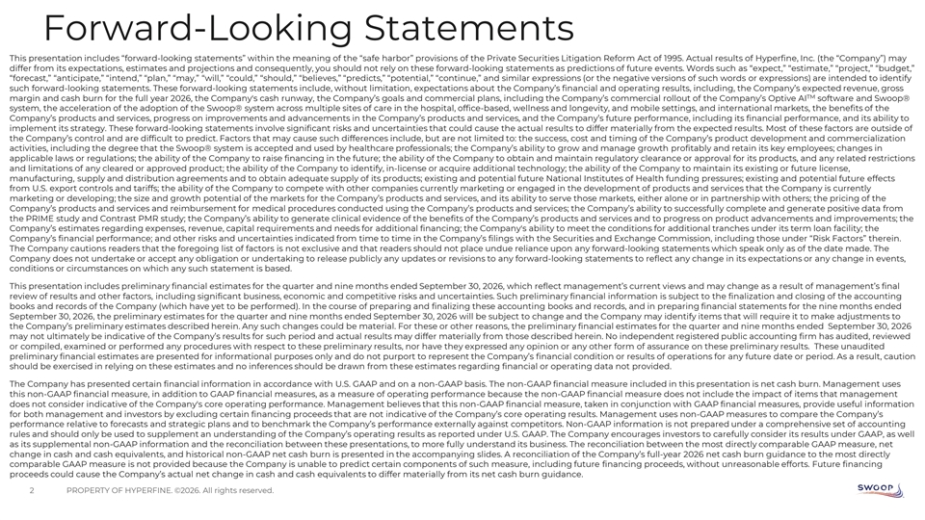
Forward-Looking Statements This presentation includes “forward-looking statements” within the meaning of the “safe harbor” provisions of the Private Securities Litigation Reform Act of 1995. Actual results of Hyperfine, Inc. (the “Company”) may differ from its expectations, estimates and projections and consequently, you should not rely on these forward-looking statements as predictions of future events. Words such as “expect,” “estimate,” “project,” “budget,” “forecast,” “anticipate,” “intend,” “plan,” “may,” “will,” “could,” “should,” “believes,” “predicts,” “potential,” “continue,” and similar expressions (or the negative versions of such words or expressions) are intended to identify such forward-looking statements. These forward-looking statements include, without limitation, expectations about the Company’s financial and operating results, including, the Company’s expected revenue, gross TM margin and cash burn for the full year 2026, the Company's cash runway, the Company’s goals and commercial plans, including the Company’s commercial rollout of the Company’s Optive AI software and Swoop® system, the acceleration of the adoption of the Swoop® system across multiple sites of care in the hospital, office-based, wellness and longevity, and mobile settings, and international markets, the benefits of the Company’s products and services, progress on improvements and advancements in the Company’s products and services, and the Company’s future performance, including its financial performance, and its ability to implement its strategy. These forward-looking statements involve significant risks and uncertainties that could cause the actual results to differ materially from the expected results. Most of these factors are outside of the Company’s control and are difficult to predict. Factors that may cause such differences include, but are not limited to: the success, cost and timing of the Company’s product development and commercialization activities, including the degree that the Swoop® system is accepted and used by healthcare professionals; the Company’s ability to grow and manage growth profitably and retain its key employees; changes in applicable laws or regulations; the ability of the Company to raise financing in the future; the ability of the Company to obtain and maintain regulatory clearance or approval for its products, and any related restrictions and limitations of any cleared or approved product; the ability of the Company to identify, in-license or acquire additional technology; the ability of the Company to maintain its existing or future license, manufacturing, supply and distribution agreements and to obtain adequate supply of its products; existing and potential future National Institutes of Health funding pressures; existing and potential future effects from U.S. export controls and tariffs; the ability of the Company to compete with other companies currently marketing or engaged in the development of products and services that the Company is currently marketing or developing; the size and growth potential of the markets for the Company’s products and services, and its ability to serve those markets, either alone or in partnership with others; the pricing of the Company’s products and services and reimbursement for medical procedures conducted using the Company’s products and services; the Company’s ability to successfully complete and generate positive data from the PRIME study and Contrast PMR study; the Company’s ability to generate clinical evidence of the benefits of the Company’s products and services and to progress on product advancements and improvements; the Company’s estimates regarding expenses, revenue, capital requirements and needs for additional financing; the Company's ability to meet the conditions for additional tranches under its term loan facility; the Company’s financial performance; and other risks and uncertainties indicated from time to time in the Company’s filings with the Securities and Exchange Commission, including those under “Risk Factors” therein. The Company cautions readers that the foregoing list of factors is not exclusive and that readers should not place undue reliance upon any forward-looking statements which speak only as of the date made. The Company does not undertake or accept any obligation or undertaking to release publicly any updates or revisions to any forward-looking statements to reflect any change in its expectations or any change in events, conditions or circumstances on which any such statement is based. This presentation includes preliminary financial estimates for the quarter and nine months ended September 30, 2026, which reflect management’s current views and may change as a result of management’s final review of results and other factors, including significant business, economic and competitive risks and uncertainties. Such preliminary financial information is subject to the finalization and closing of the accounting books and records of the Company (which have yet to be performed). In the course of preparing and finalizing these accounting books and records, and in preparing financial statements for the nine months ended September 30, 2026, the preliminary estimates for the quarter and nine months ended September 30, 2026 will be subject to change and the Company may identify items that will require it to make adjustments to the Company’s preliminary estimates described herein. Any such changes could be material. For these or other reasons, the preliminary financial estimates for the quarter and nine months ended September 30, 2026 may not ultimately be indicative of the Company’s results for such period and actual results may differ materially from those described herein. No independent registered public accounting firm has audited, reviewed or compiled, examined or performed any procedures with respect to these preliminary results, nor have they expressed any opinion or any other form of assurance on these preliminary results. These unaudited preliminary financial estimates are presented for informational purposes only and do not purport to represent the Company’s financial condition or results of operations for any future date or period. As a result, caution should be exercised in relying on these estimates and no inferences should be drawn from these estimates regarding financial or operating data not provided. The Company has presented certain financial information in accordance with U.S. GAAP and on a non-GAAP basis. The non-GAAP financial measure included in this presentation is net cash burn. Management uses this non-GAAP financial measure, in addition to GAAP financial measures, as a measure of operating performance because the non-GAAP financial measure does not include the impact of items that management does not consider indicative of the Company's core operating performance. Management believes that this non-GAAP financial measure, taken in conjunction with GAAP financial measures, provide useful information for both management and investors by excluding certain financing proceeds that are not indicative of the Company’s core operating results. Management uses non-GAAP measures to compare the Company’s performance relative to forecasts and strategic plans and to benchmark the Company’s performance externally against competitors. Non-GAAP information is not prepared under a comprehensive set of accounting rules and should only be used to supplement an understanding of the Company’s operating results as reported under U.S. GAAP. The Company encourages investors to carefully consider its results under GAAP, as well as its supplemental non-GAAP information and the reconciliation between these presentations, to more fully understand its business. The reconciliation between the most directly comparable GAAP measure, net change in cash and cash equivalents, and historical non-GAAP net cash burn is presented in the accompanying slides. A reconciliation of the Company’s full-year 2026 net cash burn guidance to the most directly comparable GAAP measure is not provided because the Company is unable to predict certain components of such measure, including future financing proceeds, without unreasonable efforts. Future financing proceeds could cause the Company’s actual net change in cash and cash equivalents to differ materially from its net cash burn guidance. 2 PROPERTY OF HYPERFINE. ©2026. All rights reserved.

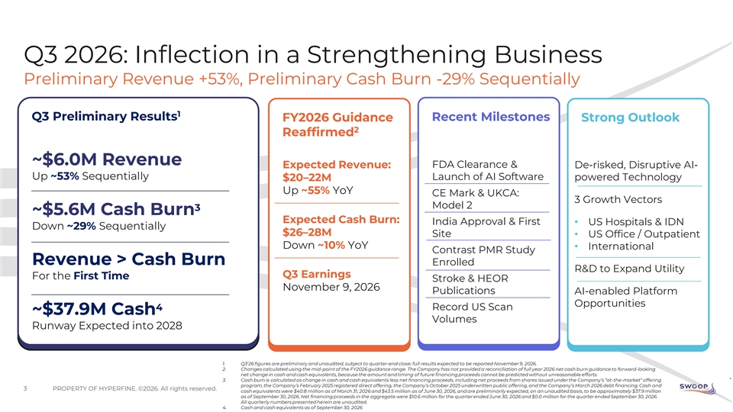
Q3 2026: Inflection in a Strengthening Business Preliminary Revenue +53%, Preliminary Cash Burn -29% Sequentially 1 Q3 Preliminary Results Recent Milestones FY2026 Guidance Strong Outlook 2 Reaffirmed ~$6.0M Revenue FDA Clearance & Expected Revenue: De-risked, Disruptive AI- Up ~53% Sequentially Launch of AI Software $20–22M powered Technology Up ~55% YoY CE Mark & UKCA: 3 Growth Vectors Model 2 3 ~$5.6M Cash Burn Expected Cash Burn: India Approval & First • US Hospitals & IDN Down ~29% Sequentially $26–28M Site • US Office / Outpatient Down ~10% YoY • International Contrast PMR Study Revenue > Cash Burn Enrolled R&D to Expand Utility Q3 Earnings For the First Time Stroke & HEOR November 9, 2026 Publications AI-enabled Platform Opportunities 4 Record US Scan ~$37.9M Cash Volumes Runway Expected into 2028 1. Q3'26 figures are preliminary and unaudited, subject to quarter-end close; full results expected to be reported November 9, 2026. 2. Changes calculated using the mid-point of the FY2026 guidance range. The Company has not provided a reconciliation of full year 2026 net cash burn guidance to forward-looking net change in cash and cash equivalents, because the amount and timing of future financing proceeds cannot be predicted without unreasonable efforts. 3. Cash burn is calculated as change in cash and cash equivalents less net financing proceeds, including net proceeds from shares issued under the Company’s “at-the-market” offering program, the Company’s February 2025 registered direct offering, the Company’s October 2025 underwritten public offering, and the Company’s March 2026 debt financing. Cash and 3 PROPERTY OF HYPERFINE. ©2026. All rights reserved. cash equivalents were $40.8 million as of March 31, 2026 and $43.5 million as of June 30, 2026, and are preliminarily expected, on an unaudited basis, to be approximately $37.9 million as of September 30, 2026. Net financing proceeds in the aggregate were $10.6 million for the quarter ended June 30, 2026 and $0.0 million for the quarter ended September 30, 2026. All quarterly numbers presented herein are unaudited. 4. Cash and cash equivalents as of September 30, 2026

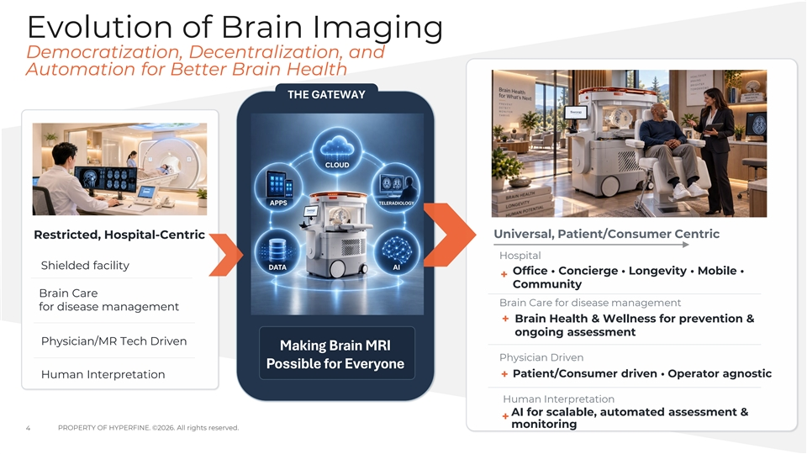
Evolution of Brain Imaging Democratization, Decentralization, and Automation for Better Brain Health THE GATEWAY Restricted, Hospital-Centric Universal, Patient/Consumer Centric Hospital Shielded facility Office • Concierge • Longevity • Mobile • + Community Brain Care Brain Care for disease management for disease management + Brain Health & Wellness for prevention & ongoing assessment Physician/MR Tech Driven Making Brain MRI Physician Driven Possible for Everyone Patient/Consumer driven • Operator agnostic Human Interpretation + Human Interpretation AI for scalable, automated assessment & + monitoring 4 PROPERTY OF HYPERFINE. ©2026. All rights reserved.

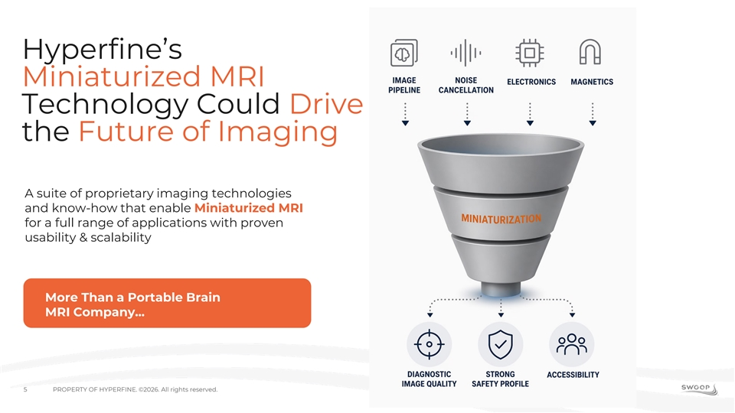
Hyperfine’s Miniaturized MRI Technology Could Drive the Future of Imaging A suite of proprietary imaging technologies and know-how that enable Miniaturized MRI for a full range of applications with proven usability & scalability More Than a Portable Brain MRI Company... 5 PROPERTY OF HYPERFINE. ©2026. All rights reserved.

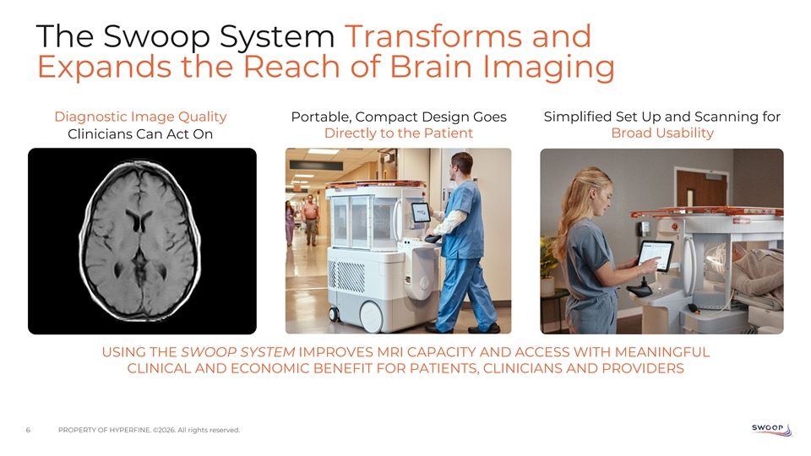
The Swoop System Transforms and Expands the Reach of Brain Imaging Diagnostic Image Quality Portable, Compact Design Goes Simplified Set Up and Scanning for Directly to the Patient Broad Usability Clinicians Can Act On USING THE SWOOP SYSTEM IMPROVES MRI CAPACITY AND ACCESS WITH MEANINGFUL CLINICAL AND ECONOMIC BENEFIT FOR PATIENTS, CLINICIANS AND PROVIDERS 6 PROPERTY OF HYPERFINE. ©2026. All rights reserved.

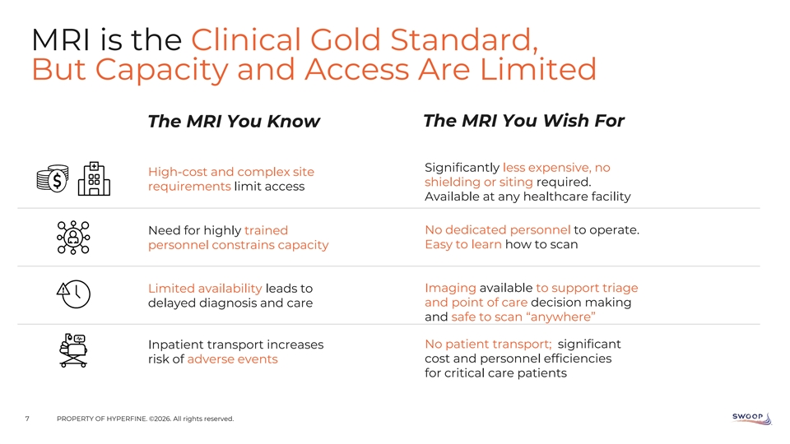
MRI is the Clinical Gold Standard, But Capacity and Access Are Limited The MRI You Know The MRI You Wish For Significantly less expensive, no High-cost and complex site shielding or siting required. requirements limit access Available at any healthcare facility Need for highly trained No dedicated personnel to operate. personnel constrains capacity Easy to learn how to scan Limited availability leads to Imaging available to support triage delayed diagnosis and care and point of care decision making and safe to scan “anywhere” Inpatient transport increases No patient transport; significant risk of adverse events cost and personnel efficiencies for critical care patients 7 PROPERTY OF HYPERFINE. ©2026. All rights reserved.

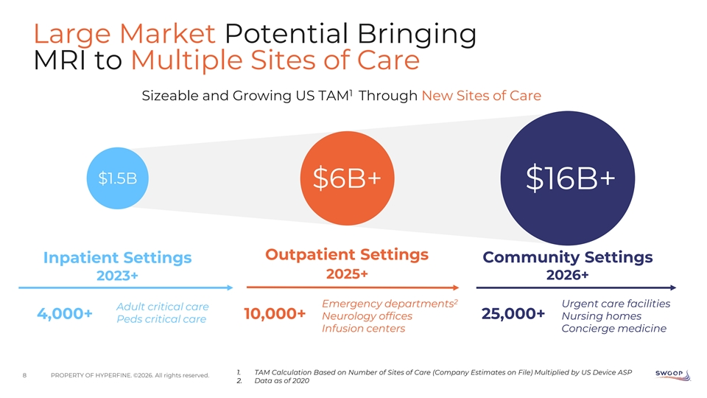
Large Market Potential Bringing MRI to Multiple Sites of Care 1 Sizeable and Growing US TAM Through New Sites of Care $1.5B $6B+ $16B+ Outpatient Settings Community Settings Inpatient Settings 2025+ 2026+ 2023+ 2 Emergency departments Urgent care facilities Adult critical care 4,000+ 10,000+ Neurology offices 25,000+ Nursing homes Peds critical care Infusion centers Concierge medicine 1. TAM Calculation Based on Number of Sites of Care (Company Estimates on File) Multiplied by US Device ASP 8 PROPERTY OF HYPERFINE. ©2026. All rights reserved. 2. Data as of 2020

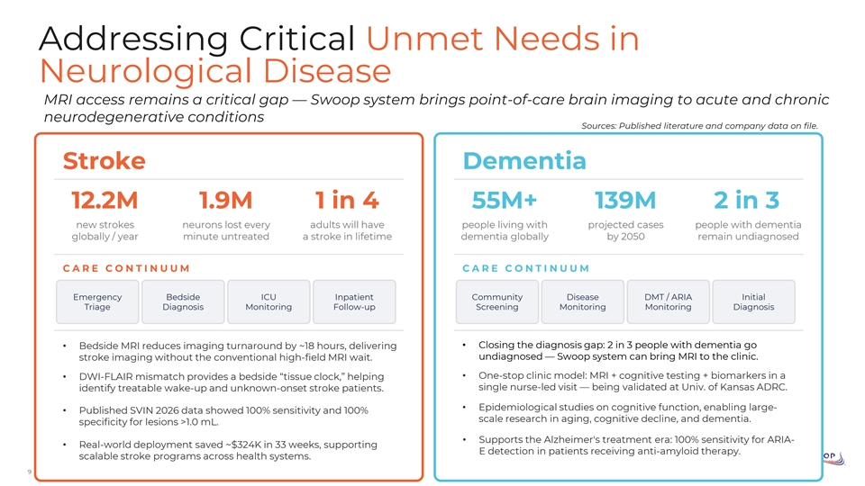
Addressing Critical Unmet Needs in Neurological Disease MRI access remains a critical gap — Swoop system brings point-of-care brain imaging to acute and chronic neurodegenerative conditions Sources: Published literature and company data on file. Stroke Dementia 12.2M 1.9M 1 in 4 55M+ 139M 2 in 3 new strokes neurons lost every adults will have people living with projected cases people with dementia globally / year minute untreated a stroke in lifetime dementia globally by 2050 remain undiagnosed CARE CO NTI NUUM CARE CO NTI NUUM Emergency Bedside ICU Inpatient Community Disease DMT / ARIA Initial Triage Diagnosis Monitoring Follow-up Screening Monitoring Monitoring Diagnosis • Closing the diagnosis gap: 2 in 3 people with dementia go • Bedside MRI reduces imaging turnaround by ~18 hours, delivering undiagnosed — Swoop system can bring MRI to the clinic. stroke imaging without the conventional high-field MRI wait. • One-stop clinic model: MRI + cognitive testing + biomarkers in a • DWI-FLAIR mismatch provides a bedside “tissue clock,” helping single nurse-led visit — being validated at Univ. of Kansas ADRC. identify treatable wake-up and unknown-onset stroke patients. • Epidemiological studies on cognitive function, enabling large- • Published SVIN 2026 data showed 100% sensitivity and 100% scale research in aging, cognitive decline, and dementia. specificity for lesions >1.0 mL. • Supports the Alzheimer's treatment era: 100% sensitivity for ARIA- • Real-world deployment saved ~$324K in 33 weeks, supporting E detection in patients receiving anti-amyloid therapy. scalable stroke programs across health systems. 9 PROPERTY OF HYPERFINE. ©2026. All rights reserved.

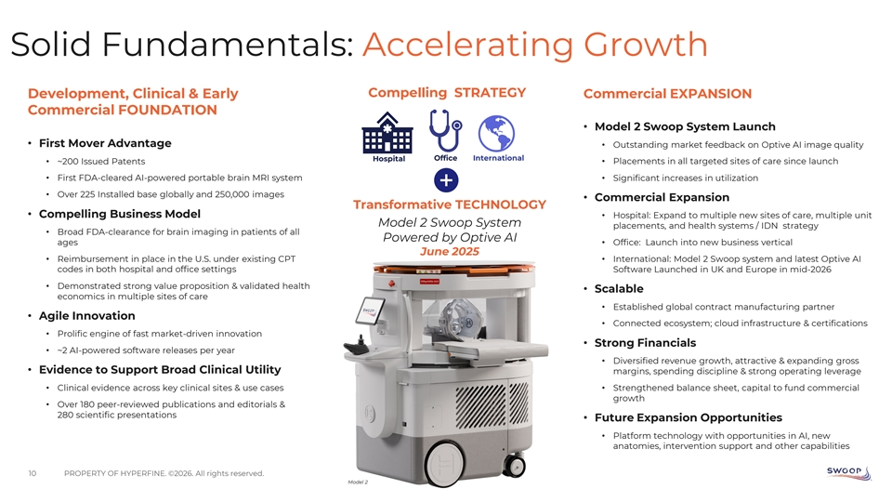
Solid Fundamentals: Accelerating Growth Development, Clinical & Early Compelling STRATEGY Commercial EXPANSION Commercial FOUNDATION • Model 2 Swoop System Launch • First Mover Advantage • Outstanding market feedback on Optive AI image quality Hospital Office International • ~200 Issued Patents • Placements in all targeted sites of care since launch • First FDA-cleared AI-powered portable brain MRI system • Significant increases in utilization • Over 225 Installed base globally and 250,000 images • Commercial Expansion Transformative TECHNOLOGY • Compelling Business Model • Hospital: Expand to multiple new sites of care, multiple unit Model 2 Swoop System placements, and health systems / IDN strategy • Broad FDA-clearance for brain imaging in patients of all Powered by Optive AI ages • Office: Launch into new business vertical June 2025 • Reimbursement in place in the U.S. under existing CPT • International: Model 2 Swoop system and latest Optive AI codes in both hospital and office settings Software Launched in UK and Europe in mid-2026 • Demonstrated strong value proposition & validated health • Scalable economics in multiple sites of care • Established global contract manufacturing partner • Agile Innovation • Connected ecosystem; cloud infrastructure & certifications • Prolific engine of fast market-driven innovation • Strong Financials • ~2 AI-powered software releases per year • Diversified revenue growth, attractive & expanding gross • Evidence to Support Broad Clinical Utility margins, spending discipline & strong operating leverage • Clinical evidence across key clinical sites & use cases • Strengthened balance sheet, capital to fund commercial growth • Over 180 peer-reviewed publications and editorials & 280 scientific presentations • Future Expansion Opportunities • Platform technology with opportunities in AI, new anatomies, intervention support and other capabilities 10 PROPERTY OF HYPERFINE. ©2026. All rights reserved. Model 2

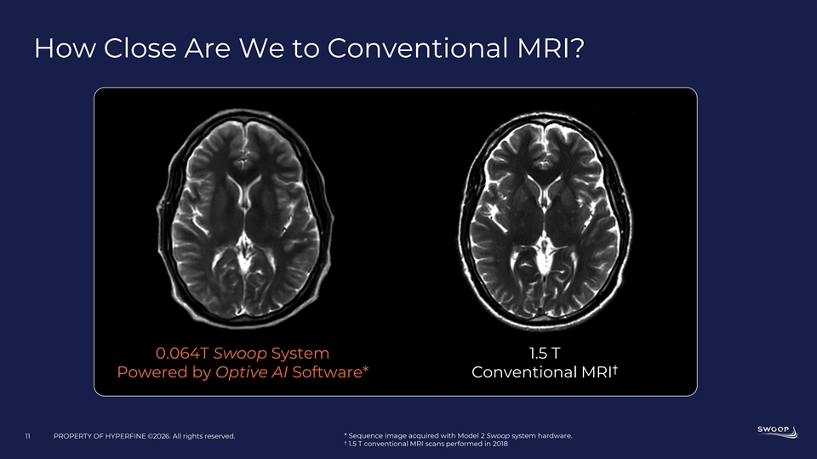
How Close Are We to Conventional MRI? 0.064T Swoop System 1.5 T † Powered by Optive AI Software* Conventional MRI 11 PROPERTY OF HYPERFINE ©2026. All rights reserved. * Sequence image acquired with Model 2 Swoop system hardware. † 1.5 T conventional MRI scans performed in 2018

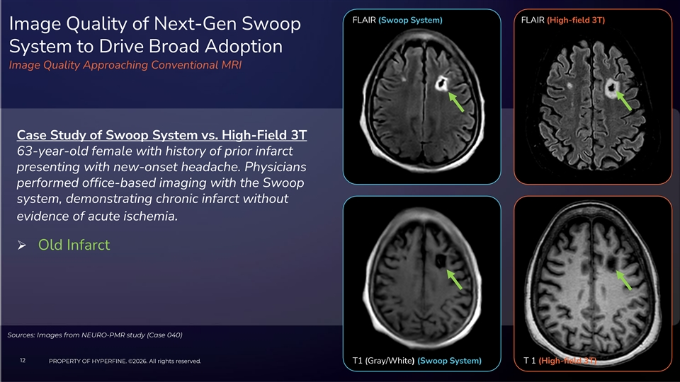
FLAIR (Swoop System) FLAIR (High-field 3T) Image Quality of Next-Gen Swoop System to Drive Broad Adoption Image Quality Approaching Conventional MRI Case Study of Swoop System vs. High-Field 3T 63-year-old female with history of prior infarct presenting with new-onset headache. Physicians performed office-based imaging with the Swoop system, demonstrating chronic infarct without evidence of acute ischemia. Ø Old Infarct Sources: Images from NEURO-PMR study (Case 040) 12 PROPERTY OF HYPERFINE. ©2026. All rights reserved. T1 (Gray/White) (Swoop System) T 1 (High-field 3T)


AI-Enabled Imaging Software Advanced, AI-driven image reconstruction to ultra-low field MRI—unlocking clearer images at lower field strengths Reduces noise and blur with deep learning, enhances image clarity and consistency, provides sharper anatomical detail to support confident diagnoses at the point of care 12 Generations of AI-enabled software A leader in FDA cleared AI-enabled devices POWERING THE FUTURE OF PORTABLE MRI Available on all Swoop systems . Source: U.S. FDA Artificial Intelligence-Enabled Medical Devices List (June 30, 2026) 13 PROPERTY OF HYPERFINE. ©2026. All rights reserved. .

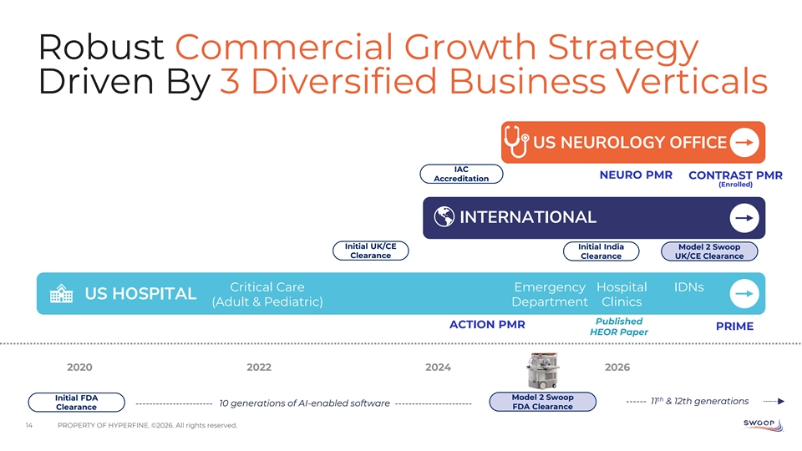
Robust Commercial Growth Strategy Driven By 3 Diversified Business Verticals US NEUROLOGY OFFICE IAC NEURO PMR CONTRAST PMR Accreditation (Enrolled) INTERNATIONAL Initial UK/CE Initial India Model 2 Swoop Clearance Clearance UK/CE Clearance Critical Care Emergency Hospital IDNs US HOSPITAL (Adult & Pediatric) Department Clinics Published ACTION PMR PRIME HEOR Paper 2020 2022 2024 2026 Model 2 Swoop Initial FDA th ------ 11 & 12th generations ----------------------- 10 generations of AI-enabled software ----------------------- Clearance FDA Clearance 14 PROPERTY OF HYPERFINE. ©2026. All rights reserved.

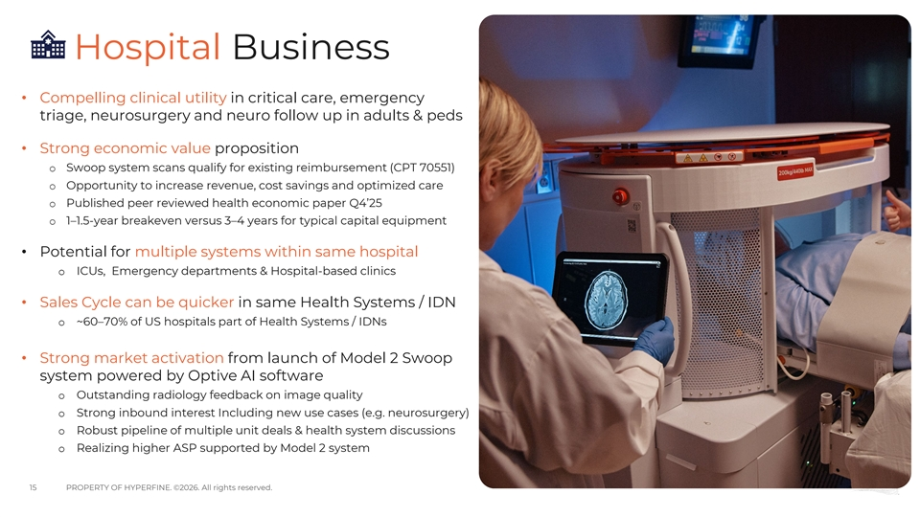
Hospital Business • Compelling clinical utility in critical care, emergency triage, neurosurgery and neuro follow up in adults & peds • Strong economic value proposition o Swoop system scans qualify for existing reimbursement (CPT 70551) o Opportunity to increase revenue, cost savings and optimized care o Published peer reviewed health economic paper Q4’25 o 1–1.5-year breakeven versus 3–4 years for typical capital equipment • Potential for multiple systems within same hospital o ICUs, Emergency departments & Hospital-based clinics • Sales Cycle can be quicker in same Health Systems / IDN o ~60–70% of US hospitals part of Health Systems / IDNs • Strong market activation from launch of Model 2 Swoop system powered by Optive AI software o Outstanding radiology feedback on image quality o Strong inbound interest Including new use cases (e.g. neurosurgery) o Robust pipeline of multiple unit deals & health system discussions o Realizing higher ASP supported by Model 2 system 15 PROPERTY OF HYPERFINE. ©2026. All rights reserved.

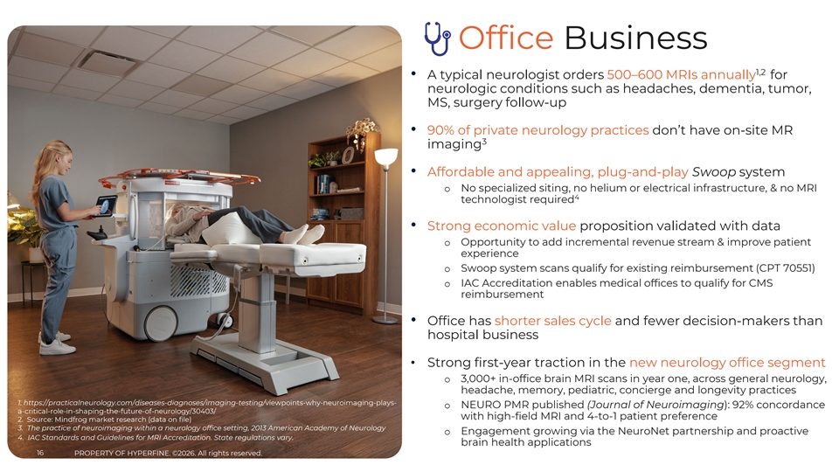
Office Business 1,2 • A typical neurologist orders 500–600 MRIs annually for neurologic conditions such as headaches, dementia, tumor, MS, surgery follow-up • 90% of private neurology practices don’t have on-site MR 3 imaging • Affordable and appealing, plug-and-play Swoop system o No specialized siting, no helium or electrical infrastructure, & no MRI 4 technologist required • Strong economic value proposition validated with data o Opportunity to add incremental revenue stream & improve patient experience o Swoop system scans qualify for existing reimbursement (CPT 70551) o IAC Accreditation enables medical offices to qualify for CMS reimbursement • Office has shorter sales cycle and fewer decision-makers than hospital business • Strong first-year traction in the new neurology office segment o 3,000+ in-office brain MRI scans in year one, across general neurology, headache, memory, pediatric, concierge and longevity practices 1. https://practicalneurology.com/diseases-diagnoses/imaging-testing/viewpoints-why-neuroimaging-plays- o NEURO PMR published (Journal of Neuroimaging): 92% concordance a-critical-role-in-shaping-the-future-of-neurology/30403/ with high-field MRI and 4-to-1 patient preference 2. Source: Mindfrog market research (data on file) 3. The practice of neuroimaging within a neurology office setting, 2013 American Academy of Neurology o Engagement growing via the NeuroNet partnership and proactive 4. IAC Standards and Guidelines for MRI Accreditation. State regulations vary. brain health applications PROPERTY OF HYPERFINE. ©2026. All rights reserved. 16 PROPERTY OF HYPERFINE. ©2026. All rights reserved.

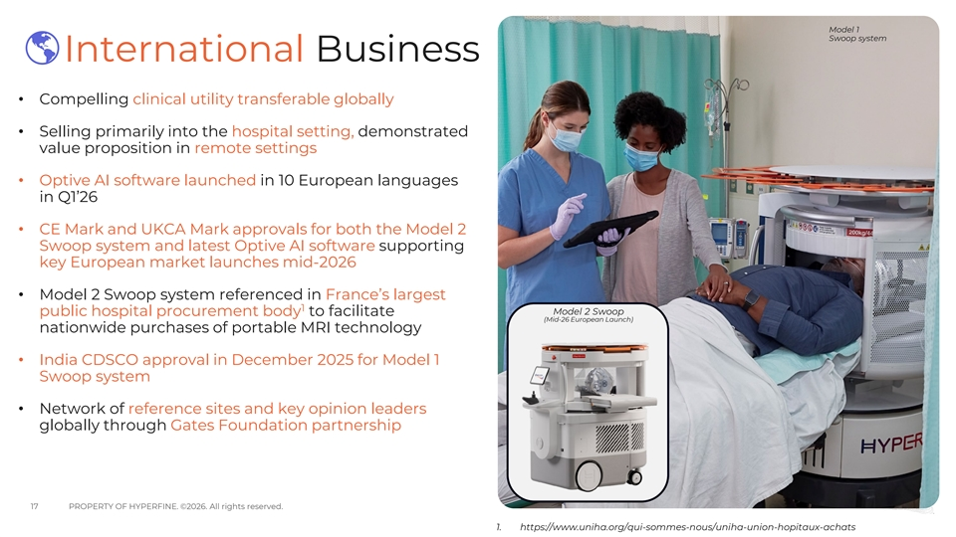
Model 1 Swoop system International Business • Compelling clinical utility transferable globally • Selling primarily into the hospital setting, demonstrated value proposition in remote settings • Optive AI software launched in 10 European languages in Q1’26 • CE Mark and UKCA Mark approvals for both the Model 2 Swoop system and latest Optive AI software supporting key European market launches mid-2026 • Model 2 Swoop system referenced in France’s largest 1 Model 2 Swoop public hospital procurement body to facilitate (Mid-26 European Launch) nationwide purchases of portable MRI technology • India CDSCO approval in December 2025 for Model 1 Swoop system • Network of reference sites and key opinion leaders globally through Gates Foundation partnership 17 PROPERTY OF HYPERFINE. ©2026. All rights reserved. 1. https://www.uniha.org/qui-sommes-nous/uniha-union-hopitaux-achats

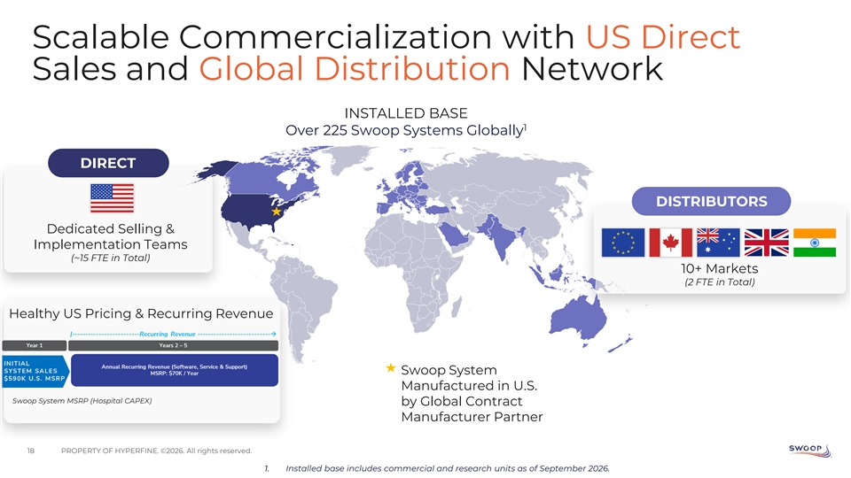
Scalable Commercialization with US Direct Sales and Global Distribution Network INSTALLED BASE 1 Over 225 Swoop Systems Globally DIRECT DISTRIBUTORS Dedicated Selling & Implementation Teams (~15 FTE in Total) 10+ Markets (2 FTE in Total) Healthy US Pricing & Recurring Revenue Swoop System Manufactured in U.S. Swoop System MSRP (Hospital CAPEX) by Global Contract Manufacturer Partner 18 PROPERTY OF HYPERFINE. ©2026. All rights reserved. 1. Installed base includes commercial and research units as of September 2026.

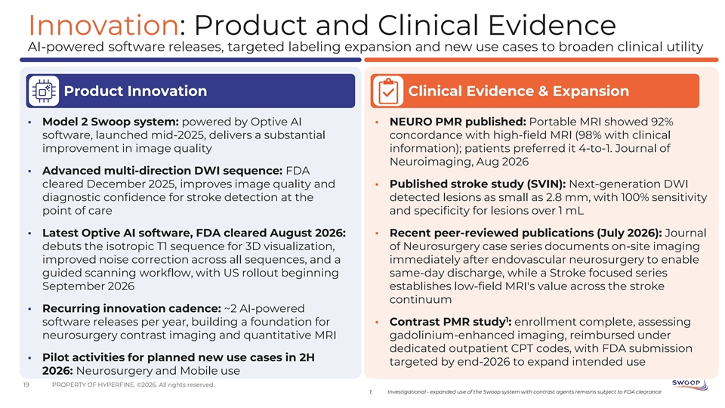
Innovation: Product and Clinical Evidence AI-powered software releases, targeted labeling expansion and new use cases to broaden clinical utility Product Innovation Clinical Evidence & Expansion ▪ Model 2 Swoop system: powered by Optive AI ▪ NEURO PMR published: Portable MRI showed 92% software, launched mid-2025, delivers a substantial concordance with high-field MRI (98% with clinical improvement in image quality information); patients preferred it 4-to-1. Journal of Neuroimaging, Aug 2026 ▪ Advanced multi-direction DWI sequence: FDA cleared December 2025, improves image quality and ▪ Published stroke study (SVIN): Next-generation DWI diagnostic confidence for stroke detection at the detected lesions as small as 2.8 mm, with 100% sensitivity point of care and specificity for lesions over 1 mL ▪ Latest Optive AI software, FDA cleared August 2026: ▪ Recent peer-reviewed publications (July 2026): Journal debuts the isotropic T1 sequence for 3D visualization, of Neurosurgery case series documents on-site imaging improved noise correction across all sequences, and a immediately after endovascular neurosurgery to enable guided scanning workflow, with US rollout beginning same-day discharge, while a Stroke focused series September 2026 establishes low-field MRI's value across the stroke continuum ▪ Recurring innovation cadence: ~2 AI-powered 1 software releases per year, building a foundation for ▪ Contrast PMR study : enrollment complete, assessing neurosurgery contrast imaging and quantitative MRI gadolinium-enhanced imaging, reimbursed under dedicated outpatient CPT codes, with FDA submission ▪ Pilot activities for planned new use cases in 2H targeted by end-2026 to expand intended use 2026: Neurosurgery and Mobile use 19 PROPERTY OF HYPERFINE. ©2026. All rights reserved. 1. Investigational - expanded use of the Swoop system with contrast agents remains subject to FDA clearance

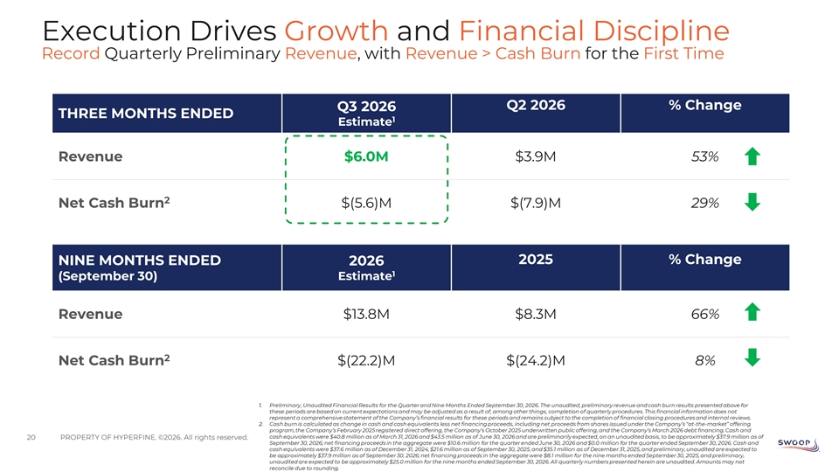
Execution Drives Growth and Financial Discipline Record Quarterly Preliminary Revenue, with Revenue > Cash Burn for the First Time Q2 2026 % Change Q3 2026 THREE MONTHS ENDED 1 Estimate Revenue $6.0M $3.9M 53% 2 Net Cash Burn $(5.6)M $(7.9)M 29% 2025 % Change NINE MONTHS ENDED 2026 1 Estimate (September 30) Revenue $13.8M $8.3M 66% 2 Net Cash Burn $(22.2)M $(24.2)M 8% 1. Preliminary, Unaudited Financial Results for the Quarter and Nine Months Ended September 30, 2026. The unaudited, preliminary revenue and cash burn results presented above for these periods are based on current expectations and may be adjusted as a result of, among other things, completion of quarterly procedures. This financial information does not represent a comprehensive statement of the Company’s financial results for these periods and remains subject to the completion of financial closing procedures and internal reviews. 2. Cash burn is calculated as change in cash and cash equivalents less net financing proceeds, including net proceeds from shares issued under the Company’s “at-the-market” offering program, the Company’s February 2025 registered direct offering, the Company’s October 2025 underwritten public offering, and the Company’s March 2026 debt financing. Cash and cash equivalents were $40.8 million as of March 31, 2026 and $43.5 million as of June 30, 2026 and are preliminarily expected, on an unaudited basis, to be approximately $37.9 million as of 20 PROPERTY OF HYPERFINE. ©2026. All rights reserved. September 30, 2026; net financing proceeds in the aggregate were $10.6 million for the quarter ended June 30, 2026 and $0.0 million for the quarter ended September 30, 2026. Cash and cash equivalents were $37.6 million as of December 31, 2024, $21.6 million as of September 30, 2025, and $35.1 million as of December 31, 2025, and preliminary, unaudited are expected to be approximately $37.9 million as of September 30, 2026; net financing proceeds in the aggregate were $8.1 million for the nine months ended September 30, 2025, and preliminary, unaudited are expected to be approximately $25.0 million for the nine months ended September 30, 2026. All quarterly numbers presented herein are unaudited. Amounts may not reconcile due to rounding.

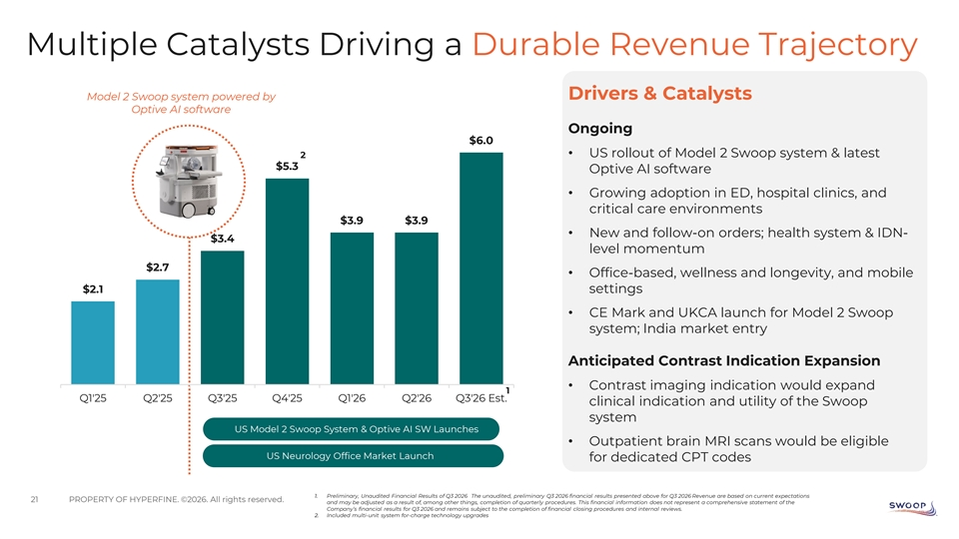
Multiple Catalysts Driving a Durable Revenue Trajectory Drivers & Catalysts Model 2 Swoop system powered by Optive AI software Ongoing $6.0 6 • US rollout of Model 2 Swoop system & latest 2 $5.3 Optive AI software 5 • Growing adoption in ED, hospital clinics, and critical care environments $3.9 $3.9 4 • New and follow-on orders; health system & IDN- $3.4 level momentum 3 $2.7 • Office-based, wellness and longevity, and mobile $2.1 settings 2 • CE Mark and UKCA launch for Model 2 Swoop system; India market entry 1 Anticipated Contrast Indication Expansion 0 • Contrast imaging indication would expand 1 Q1'25 Q2'25 Q3'25 Q4'25 Q1'26 Q2'26 Q3'26 Est. clinical indication and utility of the Swoop system US Model 2 Swoop System & Optive AI SW Launches • Outpatient brain MRI scans would be eligible US Neurology Office Market Launch for dedicated CPT codes 1. Preliminary, Unaudited Financial Results of Q3 2026 The unaudited, preliminary Q3 2026 financial results presented above for Q3 2026 Revenue are based on current expectations 21 PROPERTY OF HYPERFINE. ©2026. All rights reserved. and may be adjusted as a result of, among other things, completion of quarterly procedures. This financial information does not represent a comprehensive statement of the Company’s financial results for Q3 2026 and remains subject to the completion of financial closing procedures and internal reviews. 2. Included multi-unit system for-charge technology upgrades

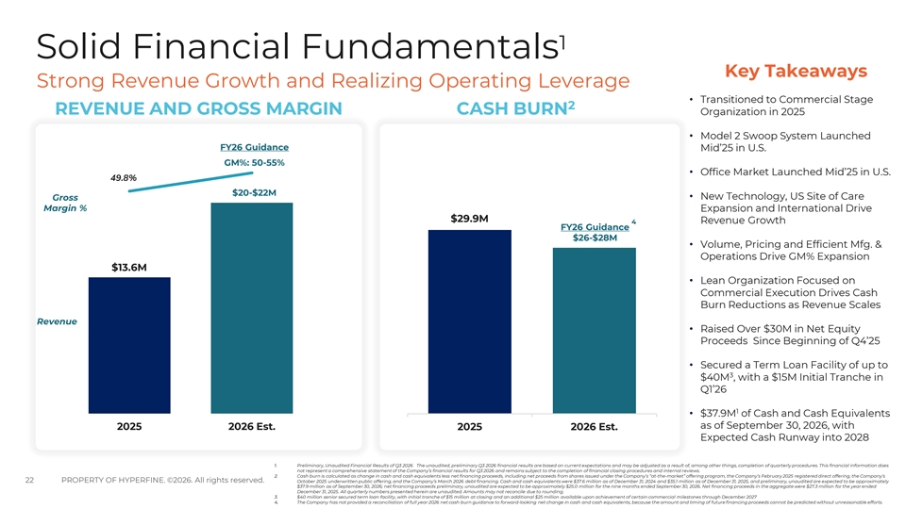
1 Solid Financial Fundamentals Key Takeaways Strong Revenue Growth and Realizing Operating Leverage • Transitioned to Commercial Stage 2 REVENUE AND GROSS MARGIN CASH BURN Organization in 2025 • Model 2 Swoop System Launched FY26 Guidance 2025 2026 Est. Mid’25 in U.S. 25 GM%: 50-55% 40 • Office Market Launched Mid’25 in U.S. 0.52 49.8% $20-$22M • New Technology, US Site of Care Gross 35 Margin % 0.47 Expansion and International Drive 20 $29.9M Revenue Growth 4 FY26 Guidance 30 $26-$28M 0.42 • Volume, Pricing and Efficient Mfg. & Operations Drive GM% Expansion 25 15 $13.6M 0.37 • Lean Organization Focused on 20 Commercial Execution Drives Cash Burn Reductions as Revenue Scales 0.32 10 Revenue 15 • Raised Over $30M in Net Equity Proceeds Since Beginning of Q4’25 0.27 10 5 • Secured a Term Loan Facility of up to 3 $40M , with a $15M Initial Tranche in 0.22 5 Q1’26 1 0 0.17 0 • $37.9M of Cash and Cash Equivalents as of September 30, 2026, with 2025 2026 Est. 2025 2026 Est. Expected Cash Runway into 2028 1. Preliminary, Unaudited Financial Results of Q3 2026 The unaudited, preliminary Q3 2026 financial results are based on current expectations and may be adjusted as a result of, among other things, completion of quarterly procedures. This financial information does not represent a comprehensive statement of the Company’s financial results for Q3 2026 and remains subject to the completion of financial closing procedures and internal reviews. 2. Cash burn is calculated as change in cash and cash equivalents less net financing proceeds, including net proceeds from shares issued under the Company’s “at-the-market” offering program, the Company’s February 2025 registered direct offering, the Company’s 22 PROPERTY OF HYPERFINE. ©2026. All rights reserved. October 2025 underwritten public offering, and the Company’s March 2026 debt financing. Cash and cash equivalents were $37.6 million as of December 31, 2024 and $35.1 million as of December 31, 2025, and preliminary, unaudited are expected to be approximately $37.9 million as of September 30, 2026; net financing proceeds preliminary, unaudited are expected to be approximately $25.0 million for the nine months ended September 30, 2026. Net financing proceeds in the aggregate were $27.3 million for the year ended December 31, 2025. All quarterly numbers presented herein are unaudited. Amounts may not reconcile due to rounding. 3. $40 million senior secured term loan facility, with initial tranche of $15 million at closing and an additional $25 million available upon achievement of certain commercial milestones through December 2027 4. The Company has not provided a reconciliation of full year 2026 net cash burn guidance to forward-looking net change in cash and cash equivalents, because the amount and timing of future financing proceeds cannot be predicted without unreasonable efforts.

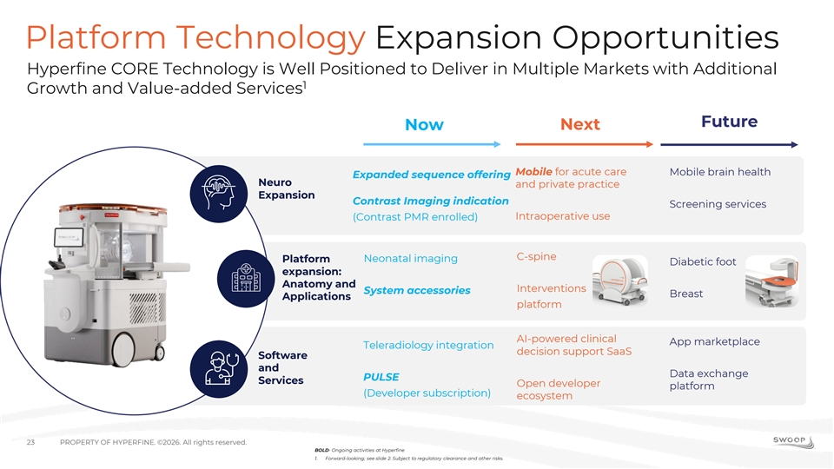
Platform Technology Expansion Opportunities Hyperfine CORE Technology is Well Positioned to Deliver in Multiple Markets with Additional 1 Growth and Value-added Services Future Next Now Mobile for acute care Mobile brain health Expanded sequence offering Neuro and private practice Expansion Contrast Imaging indication Screening services Intraoperative use (Contrast PMR enrolled) C-spine Neonatal imaging Platform Diabetic foot expansion: Anatomy and Interventions System accessories Breast Applications platform AI-powered clinical App marketplace Teleradiology integration decision support SaaS Software and Data exchange PULSE Services Open developer platform (Developer subscription) ecosystem 23 PROPERTY OF HYPERFINE. ©2026. All rights reserved. BOLD- Ongoing activities at Hyperfine 1. Forward-looking; see slide 2. Subject to regulatory clearance and other risks.

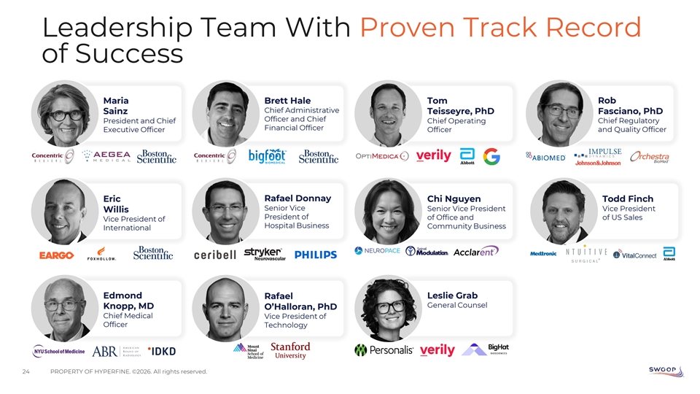
Leadership Team With Proven Track Record of Success Maria Brett Hale Tom Rob Chief Administrative Fasciano, PhD Sainz Teisseyre, PhD Officer and Chief President and Chief Chief Operating Chief Regulatory Financial Officer Executive Officer Officer and Quality Officer Rafael Donnay Eric Chi Nguyen Todd Finch Senior Vice Senior Vice President Vice President Willis President of of Office and of US Sales Vice President of Hospital Business Community Business International Edmond Leslie Grab Rafael General Counsel Knopp, MD O’Halloran, PhD Chief Medical Vice President of Officer Technology 24 PROPERTY OF HYPERFINE. ©2026. All rights reserved.

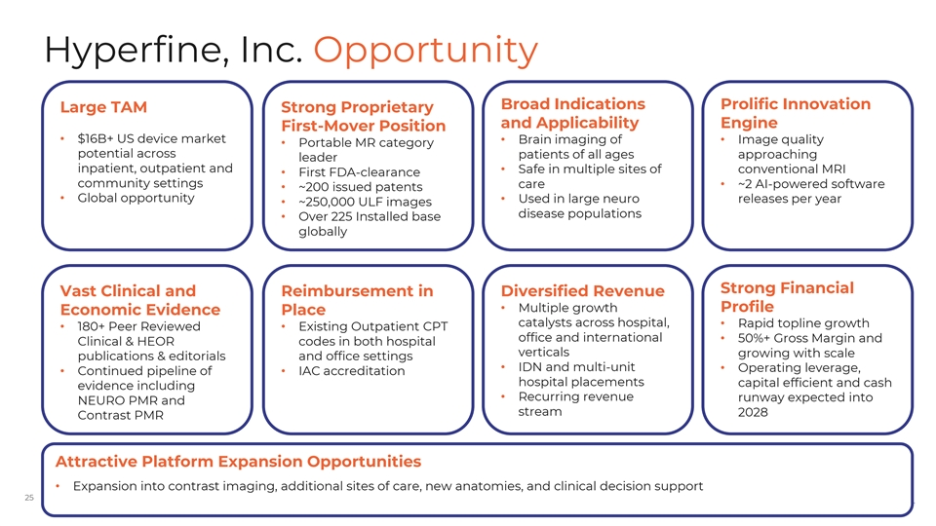
Hyperfine, Inc. Opportunity Broad Indications Prolific Innovation Large TAM Strong Proprietary and Applicability Engine First-Mover Position • $16B+ US device market • Brain imaging of • Image quality • Portable MR category potential across patients of all ages approaching leader inpatient, outpatient and • Safe in multiple sites of conventional MRI • First FDA-clearance community settings care • ~2 AI-powered software • ~200 issued patents • Global opportunity • Used in large neuro releases per year • ~250,000 ULF images disease populations • Over 225 Installed base globally Strong Financial Vast Clinical and Reimbursement in Diversified Revenue • Multiple growth Profile Economic Evidence Place catalysts across hospital, • Rapid topline growth • 180+ Peer Reviewed • Existing Outpatient CPT office and international • 50%+ Gross Margin and Clinical & HEOR codes in both hospital verticals growing with scale publications & editorials and office settings • IDN and multi-unit • Operating leverage, • Continued pipeline of • IAC accreditation hospital placements capital efficient and cash evidence including • Recurring revenue runway expected into NEURO PMR and stream 2028 Contrast PMR Attractive Platform Expansion Opportunities • Expansion into contrast imaging, additional sites of care, new anatomies, and clinical decision support PROPERTY OF HYPERFINE. ©2026. All rights reserved. 25



